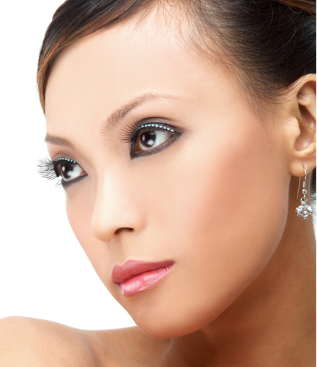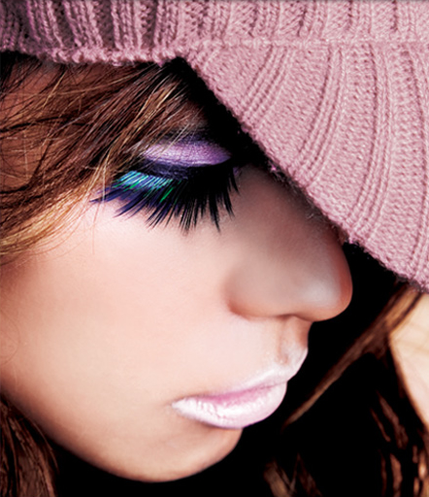

A range of daily wear soft eyelashes that can take you from the office to that hot date

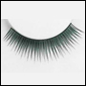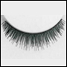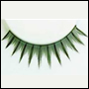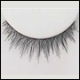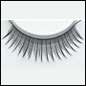

          $9.90X2.4=RM

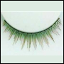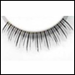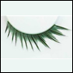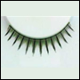

            $9.90X2.4=RM

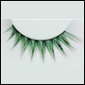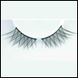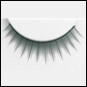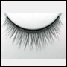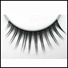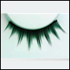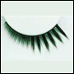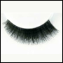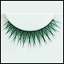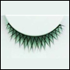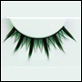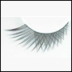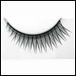

           $12.90X2.4=RM



|  |
| --- |
| A range of eyelashes that have more details for more attention. |

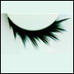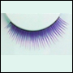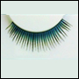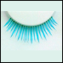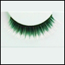

        $16.90X2.4=RM



                  $16.90X2.4=RM

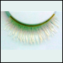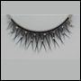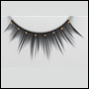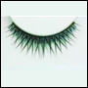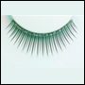

                    $16.90x2.4=RM

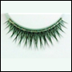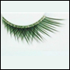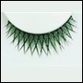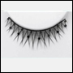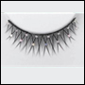

             $16.90 x 2. 4=RM

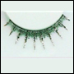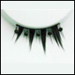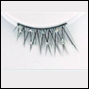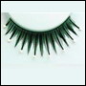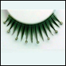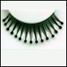

A range of more playful eyelashes.

|  |  |  |  |  |  |  |  |  |
| --- | --- | --- | --- | --- | --- | --- | --- | --- |
|  |  |  |  |  |  |  |  |  |
|  |  |  |  |  |  |  |  |  |
| $8.90 |  | $10.90 |  | $13.90 |  | $8.90 | $13.90 |  |
|  |  |  |  |  |  |  |  |  |
|  |  |  |  |  |  |  |  |  |
|  |  |  |  |  |  |  |  |  |
| $8.90 |  | $8.90 |  | $8.90 |  | $8.90 | $10.90 |  |
|  |  |  |  |  |  |  |  |  |
|  |  |  |  |  |  |  |  |  |
|  |  |  |  |  |  |  |  |  |
| $13.90 |  | $10.90 |  | $13.90 |  | $8.90 | $8.90 |  |
|  |  |  |  |  |  |  |  |  |

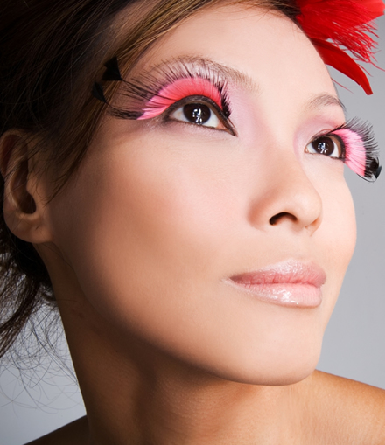

|  |
| --- |
| Dramatic eyelashes for parties, company dinners or special events. |

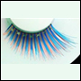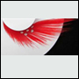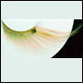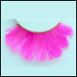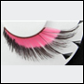

          $25.90X2.4

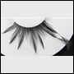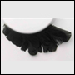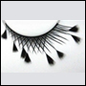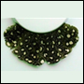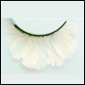

          $25.90X2.4

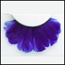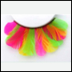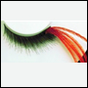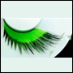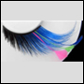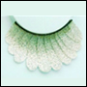

|  |
| --- |
|  |



|  |  |  |  |  |
| --- | --- | --- | --- | --- |
|  |  |  |  |  |
|  |  |  |  |  |
| * Waterproof and dries invisibly.   $9.90 |  | * Convenient and can be used for up to 10 times.   $4.90 |  | * Great for helping you apply false eyelashes.   $6.90 |
|  |  |



**http://shirechinsabahtravelstation.blogspot.com**

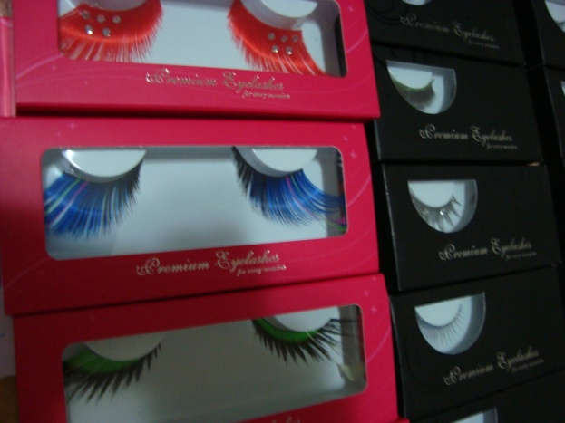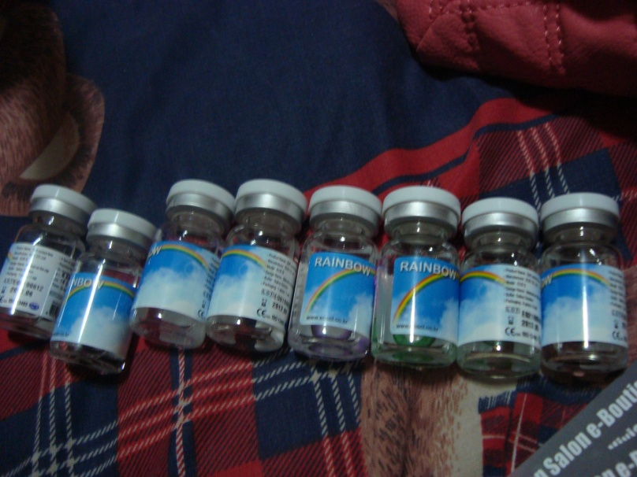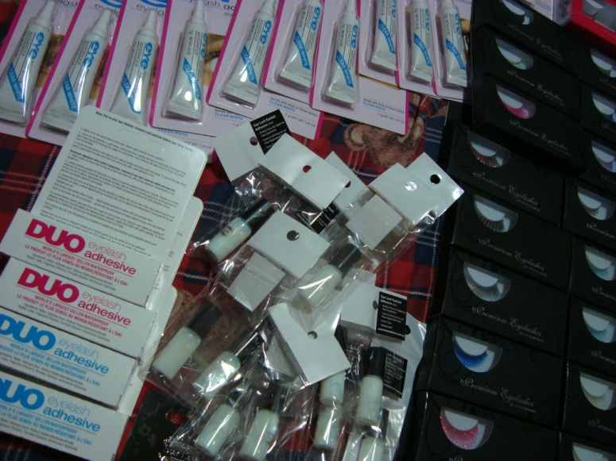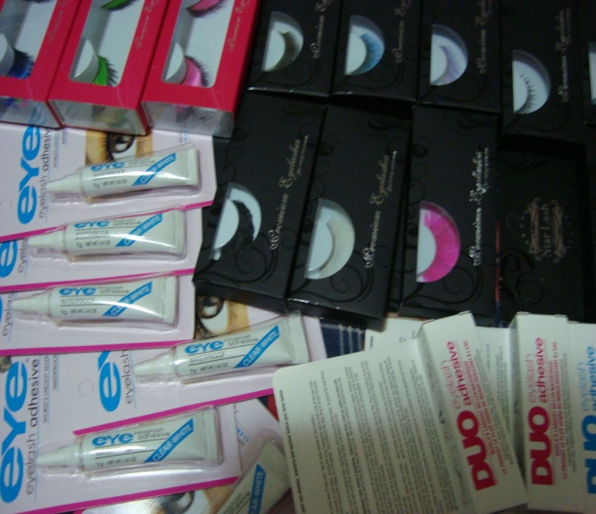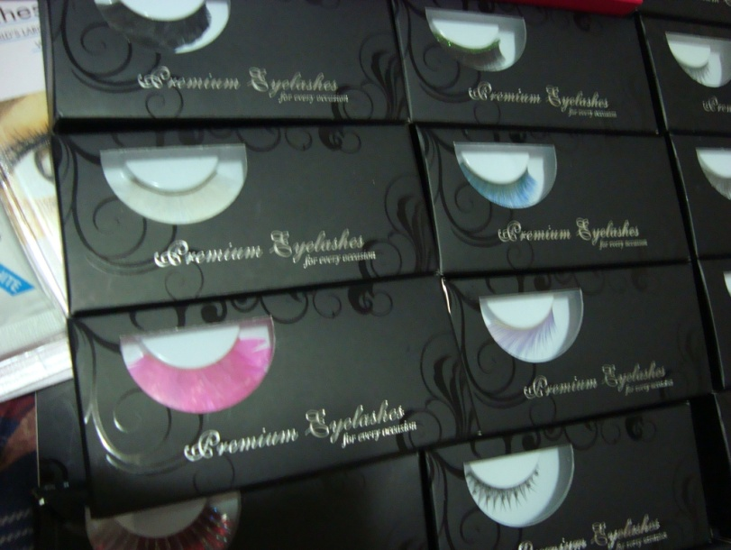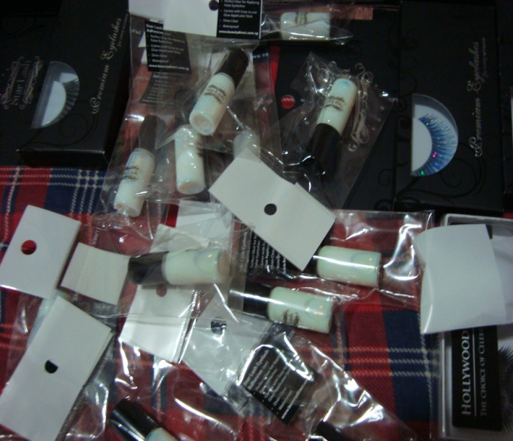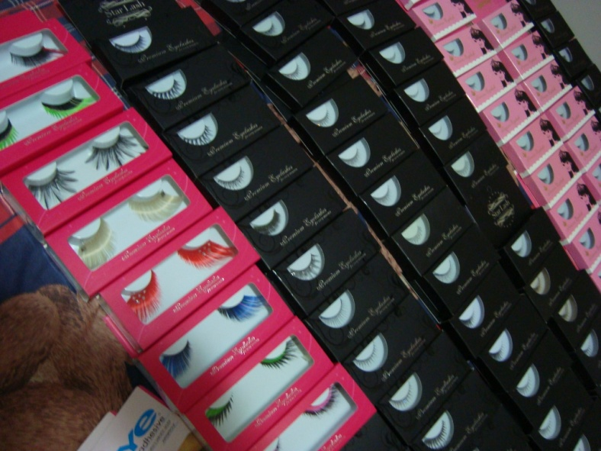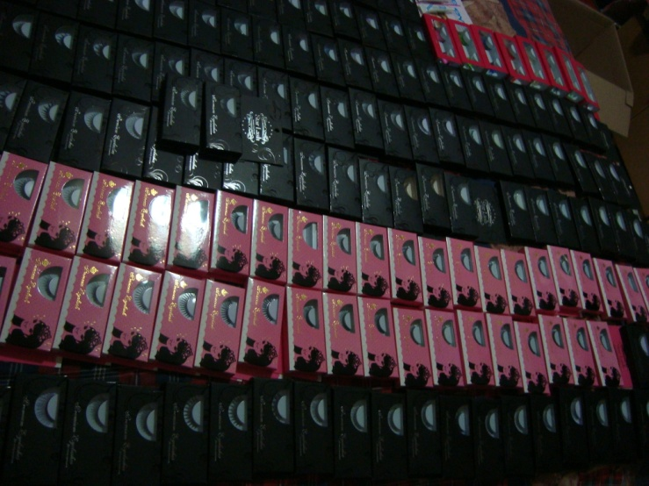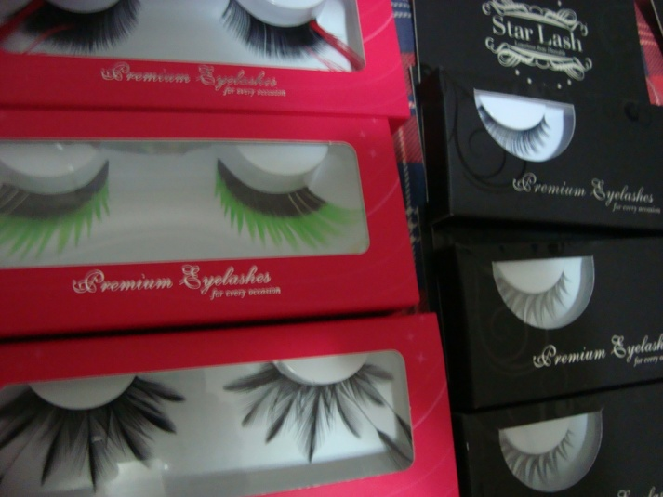

goods



How to Choose False Eyelashes

1. Zoom in on the occasion that you need the fake eyelashes first. If its for a glam night out or a hot date, consider those with glitter, diamante and even feathers. If it’s for a day in the office, choose those without any adornments in black or brown colour.
2. After you’ve decided on that, decide what look you want your fake eyelashes to help you achieve. If you want your eyes to look bigger and rounder, choose fake eyelashes that are longer in the centre. If you want a more sexy look, choose designs that are longer at the outer corner that can elongate your eyes.
3. If you have sparse eyelashes, consider fake eyelashes that are criss-cross in design. These will help create fuller looking eyelashes. If your natural eyelids are thick and puffy, go for fake eyelashes that are longer.

How to apply False Eyelashes

You will need a pair of sharp scissors, tweezers, eyelash adhesive, eyelash curler, eyelash applicator (optional), eyeliner (optional) and mascara (optional).

1. Gently curl your natural eyelashes with an eyelash curler. Some people like to draw their eyeliner at this stage. This will help the fake eyelash band disappear into your eyelash base better and appear more natural. You can also choose to apply your eyeliner after the fake eyelashes have been applied.
2. Remove your false eyelashes from the tray with a pair of tweezers gently and flex the eyelash band.
3. Put the whole fake eyelash to your eye and gauge the length. If the fake eyelashes are too wide for your eyes, trim the outer corner to the length you desire.
4. Apply a few drops of eyelash adhesive to the lash band. Do not apply the adhesive directly to your eyelids. Wait a few seconds for the adhesive to become tacky.
5. Position your fake eyelashes along your eyelash base, beginning at the inner corner of the eye. Press gently across the entire fake eyelash.
6. If you wish, you can apply mascara on your natural as well as fake eyelashes to blend the colour and make them look more natural. This is optional and is not necessary with Star Lash.

How to remove False Eyelashes

To remove fake eyelashes, use a cotton ball soaked with warm water to soften the glue and gently peel off from the inner corner of the eyes. It is important to be gentle and not peel off your own eyelashes in the process.

How to care for your False Eyelashes

After removing your false eyelashes, wash off any mascara or eyeliner with warm water, pat them dry and place them back on the eyelash tray. You will find that you will be able to re-use them for many times if you take proper care with them. And it gets easier to re-use the false eyelashes as you do not have to trim them anymore.

Fun Ways to wear your False Eyelashes

1. Lower Lash Glamour:  
   After trimming your false eyelashes, do not throw away the short portion. You can use them to line your lower lashes. To do so, apply eyeliner on the lower lash line. Apply some eyelash adhesive to the short, unwanted portion of the fake eyelashes you trimmed off. Place them at the outer corner of the lower lash line and voila! A new look!
2. Layering  
   Choose 2 complimentary looking fake eyelashes and layer them on top of each other to create your very own design!

How to Customize your very own False Eyelashes

1. Diamante  
   Let out the drama mama in you! Stick on various coloured diamante on your fake eyelashes to create your very own look.
2. Glitter  
   Pile on glitter mascara on your fake eyelashes to create different coloured eyelashes everytime your wear them!



1. Half Lash   
   Trim the fake eyelashes in half and wear them only at the outer corner of your eyes!

